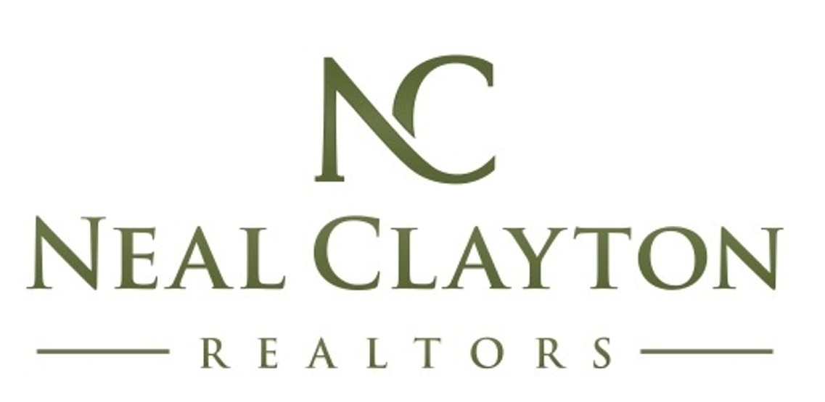

BUYER MUST HAVES

What are the three most important things for you to have in a new home?
1.
2.
3.

HONOR AGREEMENT

The Huggins Group of Neal Clayton Realtors will be committed to you. We will listen intently to your requests and do everything we can to help you find a property that meets your needs. We will only show you homes most suited to your needs. We will show you no more than 7 homes at a time. We will review homes after each showing and adjust your search as necessary. If we cannot find you a home that meets your needs after 25 showings, you have the right to terminate our honor agreement. Upon selecting your dream home, we will perform a comparative market analysis, write up the offer paperwork, present your offer, and negotiate on your behalf. We will cater to you and coordinate all aspects of the sale and closing.

_____________________________ agree(s) to be loyal and only view properties with The Huggins Group. Understanding the time it requires to facilitate, you agree to give a minimum of 4 hours notice to schedule any home showing. We can help you view and buy For Sale by Owner, resale, and new construction properties. If you visit any new home communities or open houses, you agree to let the builder representative or listing agent know that you are working with our team and register us as your representatives. Regardless of the type of home you decide to purchase, our commission is paid by the seller and the only cost for our services is a $495 brokerage fee.

________________________ __________
BUYER DATE
________________________ __________
BUYER DATE
________________________ __________
THE HUGGINS GROUP DATE

